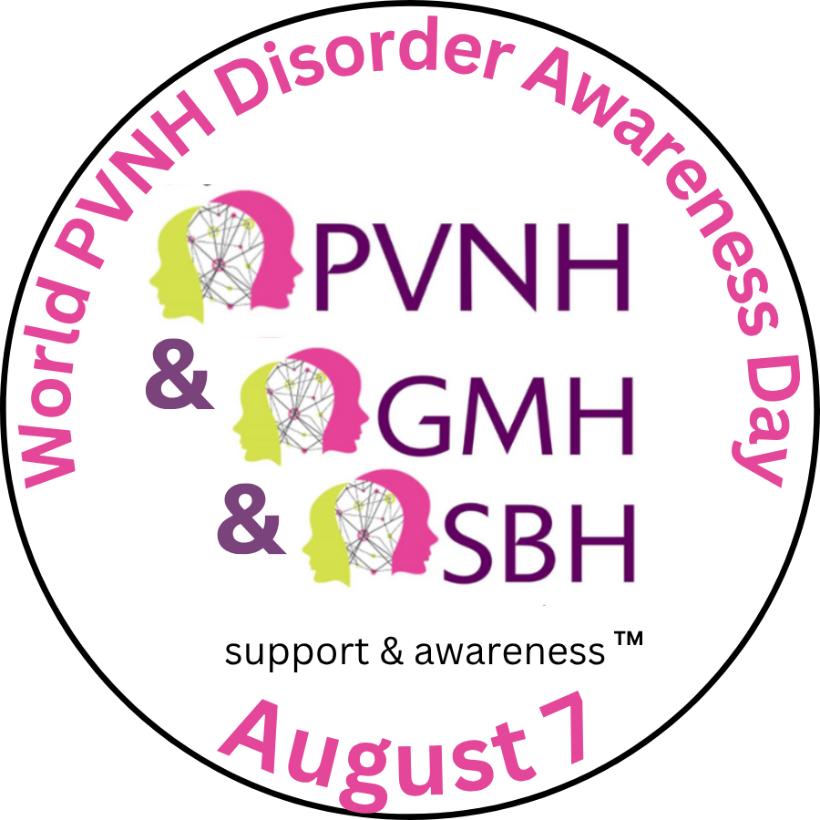
FOR IMMEDIATE RELEASE

One Little Girl's Legacy Now Lights Landmarks Across Three Countries

Canada launches the 15th World PVNH Day with landmark illuminations across Canada
Vancouver, Canada– August 6, 2026 — When Vancouver mother Yolaine Dupont lost her seven-month-old daughter, Ella, to an undiagnosed rare multisystemic disorder, she made a promise: no family should have to face that journey alone.
Almost 18 years later, that promise has become an international movement.
On August 7, landmarks across Australia, Canada and the United States will illuminate in pink and yellow to mark the 15th anniversary of World PVNH Day, the world's only international awareness campaign dedicated to Periventricular Nodular Heterotopia (PVNH), while also supporting people affected by Grey Matter Heterotopia (GMH) and Subcortical Band Heterotopia (SBH). Australia launched this year's campaign before illuminations continue across North America. They include CN Tower, Niagara Falls, Sails of Light at Canada Place, Nanaimo Bastion and Le centre des congrès in Québec City, among others.
PVNH is a rare and sometimes multisystemic brain disorder that commonly causes epilepsy and other lifelong neurological complications. Because awareness remains low, many individuals and families spend years searching for answers before receiving a diagnosis.
Today, the movement inspired by Ella connects more than 1,100 families in 50 countries, bringing together patients, clinicians, researchers and advocates to improve diagnosis, education, support and research.
“Ella never had the opportunity to receive the diagnosis that might have changed her future,” said Yolaine Dupont. “Every landmark that lights up starts a conversation. If that conversation helps just one family receive an earlier diagnosis, find the right specialist or realize they are not alone, then Ella’s legacy continues to make a difference.”
“PVNH awareness day is a reminder that we are not alone. It's a day we can shine a light on Elise’s rare neurological disorder Subcortical Band Heterotopia. To raise awareness, educate and a way to unite with others impacted by a neurological Heterotopia disorder from around the world.” —Carole Harrison, Mom to a child impacted by SBH, British Columbia
This day raises awareness about a condition that affects so many families in profound ways... And that awareness can translate to more research, supports for diagnosis and management, and understanding how to support our kids to live their life to their fullest potential.” — Roxanne Felix-Mah, Mom to a child impacted by PVNH, Alberta

PVNH awareness day is a reminder that we are not alone. It's a day we can shine a light on Elise’s rare neurological disorder Subcortical Band Heterotopia. To raise awareness, educate and a way to unite with others impacted by a neurological Heterotopia disorder from around the world.

- Canadians are invited to visit illuminations on August 7, wear pink and yellow, and share photos using #WorldPVNHDay #PaintItPinkAndYellow #PVNHloud #PVNHawareness #GMHawareness #SBHawareness.
Complete list of international landmark illuminations attached.

Media Contact
Yolaine Dupont
Founder, PVNH Support & Awareness
yolaine@pvnhsupport.com
+1 604-616-5171

